1. What is the value of m: m + 4 = 11

1. Express 125g as a fraction of a kilogram.

1. If the cost of one dollar is sh. 800. How many dollars can Mwanje buy with sh. 34,800?
2. The perimeter of a semi – circle is 36dm. Calculate its area.

1. A bus broke down after covering of the journey, the remaining distance to complete the journey was 150km. How long was the whole journey?
2.  of Ghai’s salary is equal to  of Adrian’s salary. If Adrian earns sh. 300,000. What is Ghai’s salary?

1. An athlete covered 100m in 5 seconds. Calculate the athlete’s speed in km/hr.

1. Using a pair of compasses, ruler and pencil, construct an angle of 750 at point B.

B

1. Simplify: 0.075 x 100 + 10 x 7.5
2. By the time Aine went to bed after her supper, her watch was reading as

shown in the diagram below

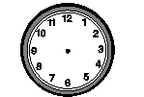 Express this time in a 24 hour clock system

1. Solve for y: 2y + 5 = y + 1
2. Martha’s mother is 23 years old and Martha is 4 years old. In how many

years will the mother be twice as old as Martha?

1. By selling a pair of shoes at sh. 72,000, a trader realizes a profit of 20%.

Calculate the cost price of the shoes.

1. Change 1011two to base three.
2. Subtract: 2x – 3 from 4x + 1.
3. Study the figure below and find the length of arc BC.

A B

14m

D C

1. An earoplane left Muscow at 8:30pm and arrived at Entebbe airport at

4:15am. How long did the flight take?

1. A tank was  litres full of water, when 800 litres were added, it became  full of water. How many litres of water are in the tank when it is  full of water?
2. Express 0.000263 in scientific form.
3. Find the base area of the cylinder below

14m

21m

**SECTION B (60 MARKS)**

1. Study the figure below and use it to answer the questions that follow.

**B** 30dm **A**

14dm

**C** **D**

1. Find the perimeter of the figure ABCD (3marks)
2. Calculate the area of the figure ABCD. (3 marks)
3. A tank has two taps that pour water into it. Tap A turned on alone fills

the tank in 20 minutes while Tap B turned on alone, fills the tank in 10

minutes.

1. How long will the two taps turned on at the same time take to fill the

tank? (2marks)

b) If both taps pour 36 litres of water per minute, what amount of water does the tank hold when full? (2marks)

1. a) Express 0.1222... as a Common fraction. ( 3marks)
2. In a class, there are 10% more boys than girls. If there are 36 girls in the class, find the total number of pupils in the class. (3marks)
3. Two dice are tossed at once. Find the chance that they show a sum of 8.

(4 marks)

1. A girl spent  of her pocket money on Onions,  of the remainder on sweets and saved the rest.

Using radius of 4cm, draw a pie chart to represent the above information.

(5marks)

1. The diagram below shows a big box which is 30cm long, 16cm wide and 9cm high and a small box which is 3cm long, 3cm wide, 3 cm high.

9cm

3cm

16cm 3cm

30cm 3cm

1. Find the total number of small boxes that will be packed in the first layer of the big box (2 marks)
2. How many layers will fill the big box? (1mark)

1. How many small boxes will fill the big box? (1mark)

1. Find the volume of the space left unoccupied after packing. (2marks)
2. a) Using a ruler, a pencil and a pair of compasses only, construct a rhombus ABCD with = 6cm and angle ADC = 60**0**. (3marks)

b) Measure diagonal AC. (1mark)

1. a) Solve for m. 4m – 6 = 12 – 2m (2marks)

b) Our Bursar is four times as old as his son. 4 years ago, their total age was

42 years. How old is the son now? (2marks)

1. Jane bought the following items from a shop as follow:-

* 2 kg of sugar at shs. 5,000 per kg.
*  kg of salt at shs. 1200 per kg.
* 3 bars of soap at shs. 3500 per bar.

If her balance was shs. 5000, how much did she have at first? (4marks)

1. a) Simplify: 0.32 x 1.2 (2marks)

0.16 x 0.1

1. Arrange 0.122, 1.22, 0.012 in ascending order (2marks)
2. The figure below is a rectangle. Use it to answer the questions that

follow:-

(3x+1)cm

(3x – 7) cm

(x+9)cm

1. Find the area of the figure above (4marks)

1. Calculate its perimeter. (2marks)

1. On the grid below;
2. Plot the points A(0,5), B (-2, 0) C(0, -3) and D (2,0)
3. Join A to B, B to C, C to D.

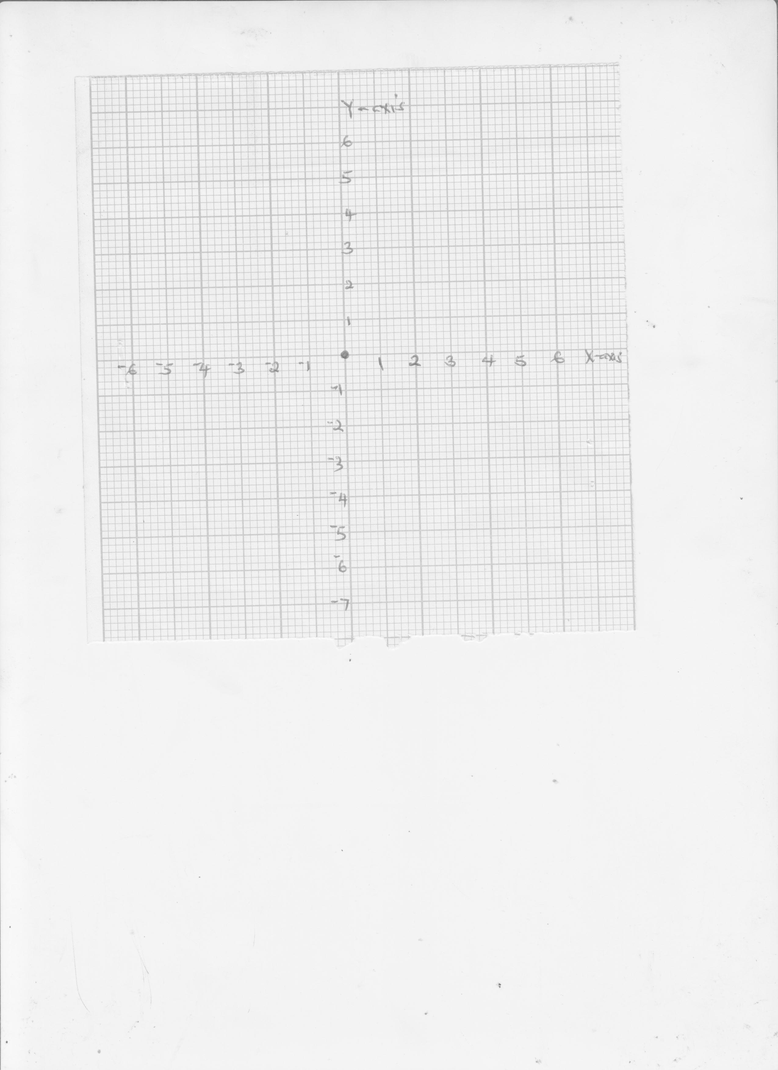

1. Name the polygon formed. __________________________(1mark)

**END**